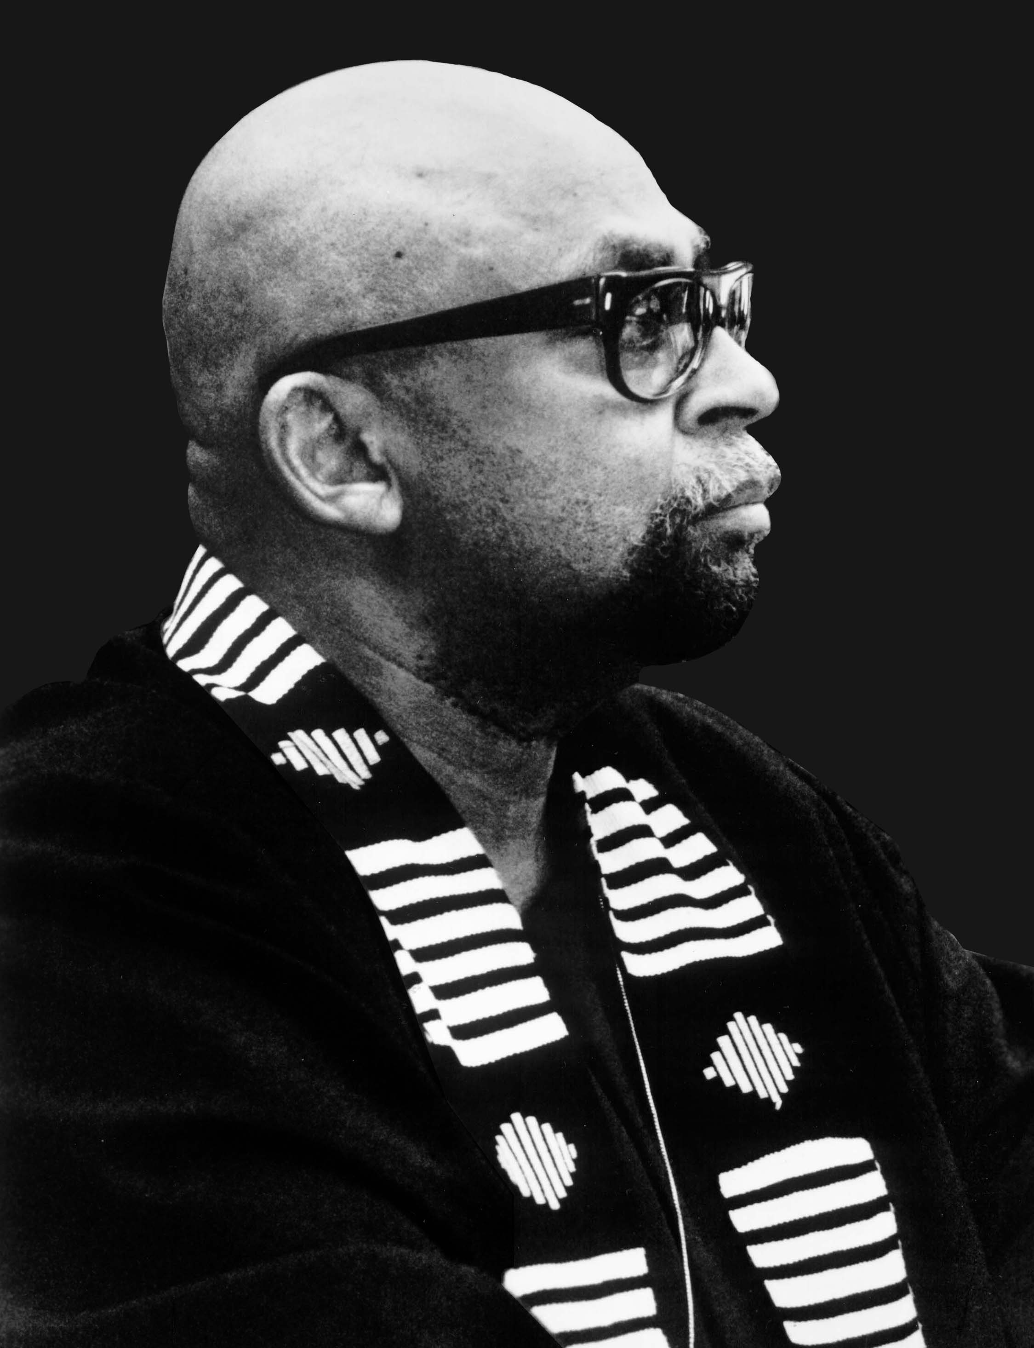
Rereading and Retrieving Douglass:
Leadership Born of Earnest Struggle
Los Angeles Sentinel, 12-10-09, p. A7
Dr. Maulana Karenga

There is no more noble or needed leadership than that which is “born of earnest struggle”, that which comes into being on the battlefield for freedom, justice and good in the world, and which understands itself as an intergenerational moral vocation in the interest of a new history and more hopeful future for humankind. The idea that leadership, especially for an oppressed people is best grounded, shaped and nurtured in struggle is suggested in Frederick Douglass’ classical speech celebrating the 23rd anniversary of freedom in the “West Indies,” calling Black leaders and Black people to increased and uncompromising struggle, and offering lessons on the philosophy and foundational role of struggle. Moreover, the men and women we honor most as great leaders, as distinguished from mere prominent position-holders, were all born and developed in the midst of earnest struggle, i.e., Harriet Tubman, Douglass himself, Sojourner Truth, Anna Julia Cooper, Marcus Garvey, Mary McLeod Bethune, Ida B. Wells-Barnett, Messenger Elijah Muhammad, Fannie Lou Hamer, Malcolm X, Ella Baker, Martin King and others.
So, it is in the fire and furnace of struggle that a people and their leaders are tested and tempered and that human freedom and flourishing are grounded and grow. Thus, Douglass says, “The whole history of the progress of human liberty shows that all concessions yet made to her august claims, have been born of earnest struggle.” It is in this struggle for human liberty or freedom, then, that real leaders of the people emerge. And again this leadership of the people in struggle is markedly different from holding a leading, prominent or directive position in a given field, i.e., sociology, economics, art, athletics, entertainment, or literature. This holds also for the field of politics which calls for representation, but not necessarily leadership in the sense offered here. For to represent politically is simply to act in a constituency’s name but not always in their interests. Thus, representation does not carry with it a strong sense of leadership, as U.S. political practice most often demonstrates.
In the classical African ethical tradition of Maat and the modern African ethical tradition of Malcolm X and Mary McLeod Bethune, leadership is a self-determined commitment and capacity to mark out and show the way, to guide and go before and along with, to instruct, inspire and aid in the self-development of the people as self-conscious agents of their own life, liberation and flourishing. The ancient Egyptian word for this is “seshem” which carries with it a profound sense of ethical obligation and poses leadership as a moral vocation as expressed in the Books of Wise Instructions in the Husia.
Douglass, speaking of struggle, makes his famous statement that “If there is no struggle, there is no progress.” Applying this maxim to leadership, we can paraphrase to say “without struggle, there is, also, no progressive leadership.” There is only compromise, disadvantaged deal-making behind closed doors or shamelessly in the open. For without a commitment to struggle, there is a tendency to accommodate rather than confront, plead rather than demand and attempt to deny and disguise the obvious disadvantage of negotiating from a position of weakness rather than of power emanating from an aware, active and united people.
Douglass goes on to say that those who seek freedom and yet denounce, disapprove or discourage struggle want success without the sacrifice required for it. He, thus, reminded the leaders and petitioners to the powerful that the rain that waters the fields of freedom requires the thunder and lightning of struggle, that the seeds of freedom can only be sown and flourish by first plowing up and overturning the ground in which they must grow and that the ocean of possibilities of a free life can only come with “the awful roar of its many waters”, a powerful metaphor for the awesome freedom cry of the masses in unrestrained and earnest struggle.
Following this reasoning, it is a fundamental and enduring Kawaida contention that the definitive solution to all our problems, especially our oppression, the overarching source of most, if not all, of them, can only be achieved in the disciplined and transformative process and practice of struggle. In a word, regardless of all other ideas and efforts applied to socially and personally generated problems, at the base and center of any solution-directed strategy must be struggle. The questions of reinforcing and rebuilding family and male/female relations, securing dignity-affirming work and decent wages, obtaining adequate health care and housing, bringing young Black men home from the self-destructive war against themselves, and cultivating quality leadership and liberating thought and practice that bring forth from us the best and most beautiful, all depend on our struggle against our weaknesses, and against the complex and savage oppression that causes, cultivates, aggravates, feeds and fosters these problems.
Douglass also reminds us that we are our own liberators and must, as a matter of self-determination and self-respect, lead and wage our own struggle, regardless of the number and sincerity of our allies. He says, “The general sentiment of mankind is, that a man who will not fight for himself, when he has the means to do so, is not worth being fought for by others, and this is a just sentiment. For a man who does not value freedom for himself will never value it for others, nor put himself to any inconvenience to gain it for others.” And those others are first and foremost of our people.
This brings us to another core and defining concept of leadership, the deep-rooted love of our people and the caring commitment to them and faith in them that this contains and requires. It is this caring commitment and faith that become the moral measure of leadership and the key to our progress as a people. As Mary McLeod Bethune states in her Sixth Legacy, Faith, “the measure of our progress as a race is in precise relation to the depth of the faith in our people held by our leaders.” This faith, she suggests, is of benefit not only to the people but also to the leaders, who because of it are strengthened in their readiness and resolve to sacrifice and struggle in the interest of the people. Thus, paraphrasing Douglass, quality leadership moves us beyond polishing and hugging the chains of oppression and holding coats for White folks to summoning the thunder, lightning and heavy rain of resistance and overturning the social and societal soil in which the seeds of freedom are sown, brought to fruition and secured for the ongoing good of the world.

Dr. Maulana Karenga, Professor of Africana Studies, California State University-Long Beach, Chair of The Organization Us, Creator of Kwanzaa, and author of Kwanzaa: A Celebration of Family, Community and Culture. www.MaulanaKarenga.org; www.Us-Organization.org; www.OfficialKwanzaaWebsite.org.

